12.07
Financial Multi Entity
Process Design & AMOS Configuration Document
Purpose
This Process Design document is provided to Key-Users to record their key decisions regarding the AMOS Process design and the required AMOS configuration.
It is updated throughout the Project Definition Phase and used as the baseline for the Final Acceptance prior to Go-Live
Revision
Author, Name | Date | Notes
Hamid Ouazi | 01.06.2024 | First Version

Table of Contents
1. Process Overview & Objectives 3
2. Regulatory References 3
3. Definitions & Glossary 3
4. Process Tasks 3
5. Process Dependencies 4
6. Process Flow 6
7. Process Design Questions 9
8. Data Source Mapping 12
9. Other Software Used 12
10. AMOS Configuration 13
a. Process specific configuration programmes 13
b. Basic Data 13
c. Parameters 14
d. Workflows 14
e. Scheduled Tasks 15
f. API’s & Interfaces 16
11. UAT Guidance 16
12. Annex – Additional Info 16

Process Overview & Objectives

Process General Description:
The purpose of this process is to manage two or several financial entities under the same AMOS environment. The multi-entity process allows to perform transactions (sales, purchases, exchanges, loan etc.) between the entities.
Main Process Objective (Outputs & Outcomes):
The main objective is to handle the transactions between the entities and to facilitate the needs for accounting and financial reporting individually per entity. Therefore, multi-entity environment in AMOS, where several companies exist in the same system, enables operational activities to be accounted for separately taking into consideration the ownership of the assets and the entity they belong to.

Regulatory References
- Accounting principles
- IFRS
- GAAP
- IAS

Definitions & Glossary

Keywords | Explanation
Financial Entity | It is a legal and financially independent company within a group of companies with their own business, financial statements, and stock value (independent average price / actual costs) that may or not consolidate to the group finance/accounting statement
IAS | International accounting standards (IAS2 related to inventory accounting principles and IAS16 related to Property Plan and Equipment (fixed assets) accounting principles)
IFRS | International Financial Reporting Standards
GAAP | Generally Accepted Accounting Principles
AP | Accounts Payables
AR | Accounts Receivables
GL | General Ledger
CoA | Chart Of Account
FOC | Free Of Charge
FS | Financial System

Process Tasks

Business Process Task / Actions / Activities:
- Create Financial Entity: new financial entity is created with entity address, entity owner, local (and functional) currency.
- Perform sales/purchase transaction between entities: AMOS creates automatically from the buying entity the creation/receiving of the purchase order and close the supplier invoice against it. In parallel, AMOS automatically generates the creation/booking of sales Order and issue and close the customer invoice.
- Perform repair (and exchange) transaction between entities: the customer entity sends the part /component to be repaired/exchanged to the repairing/exchanging entity. This process is done automatically by AMOS.
- Perform loan transaction between entities: the customer entity (lease) requests a part to be borrowed from the provider entity (lessor).
- Approve intercompany transactions.

Process Dependencies

- 12.07a Financial Multi-Entity
INPUT | CONCURRENT | OUTPUT
- 04.01 – Company Organization: Financial entities are created.

- 12.07b Multi-Entity transactions – Material Ordering
INPUT | CONCURRENT | OUTPUT
- 08.02 – Performing Maintenance: customer entity request maintenance work to the provider entity.  - 09.01 – Material planning: purchasing department is looking how to source the material.  - 11.04 – Component Maintenance: request started from the maintenance and initialise the need. | - 12.06 Budget & Cost Controlling: Cost and revenue analysis through the entity provider project and entity customer project. | - 12.01 Financial Accounting: Financial transactions are generated in both entities (customer and provider entity).  - 12.02 Invoice Checking: Intercompany supplier invoice is issued.  - 12.04 Commercial Pricing & Billing: Intercompany Customer invoice is issued.

- 12.07c Multi-Entity transactions – U/S Components
INPUT | CONCURRENT | OUTPUT
- 05.03 Repair & Exchange: removed component must be repaired or exchange from the provider entity.  - 08.04 – Parts Removal Installation: entity customer part is removed to be repaired or exchange from the provider entity.  - 12.05 Customer Quotations: Quote is issued and send to customer entity. |  | - 11.04 Component Maintenance  - 12.01 Financial Accounting: financial transactions are generated in the GL entity accordingly.  - 12.02 Invoice Checking: Intercompany supplier invoice is issued.  - 12.04 Commercial Pricing & Billing: Intercompany Customer invoice is issued.

Process Flow
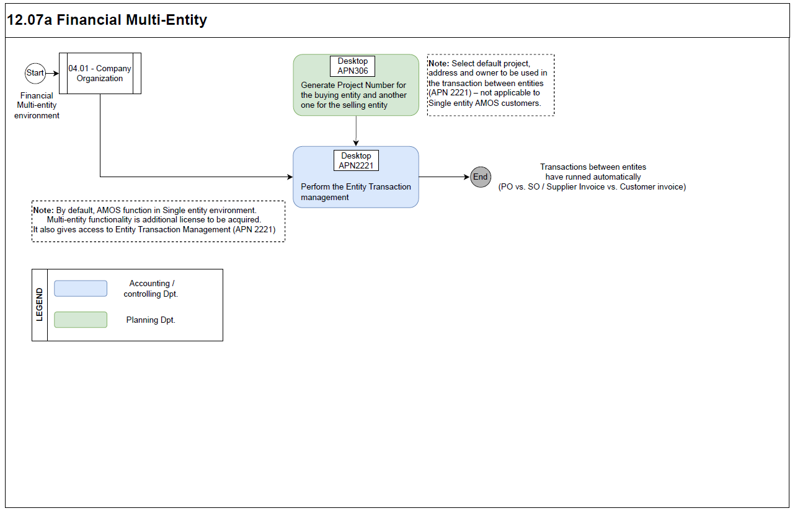

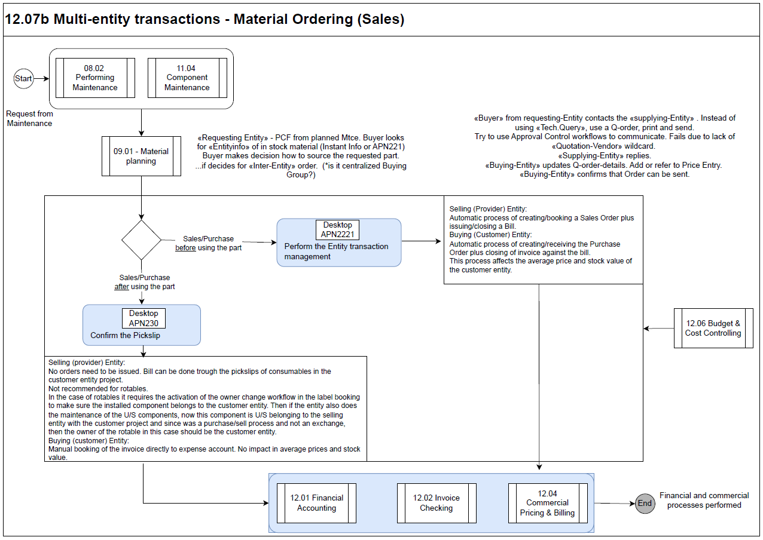
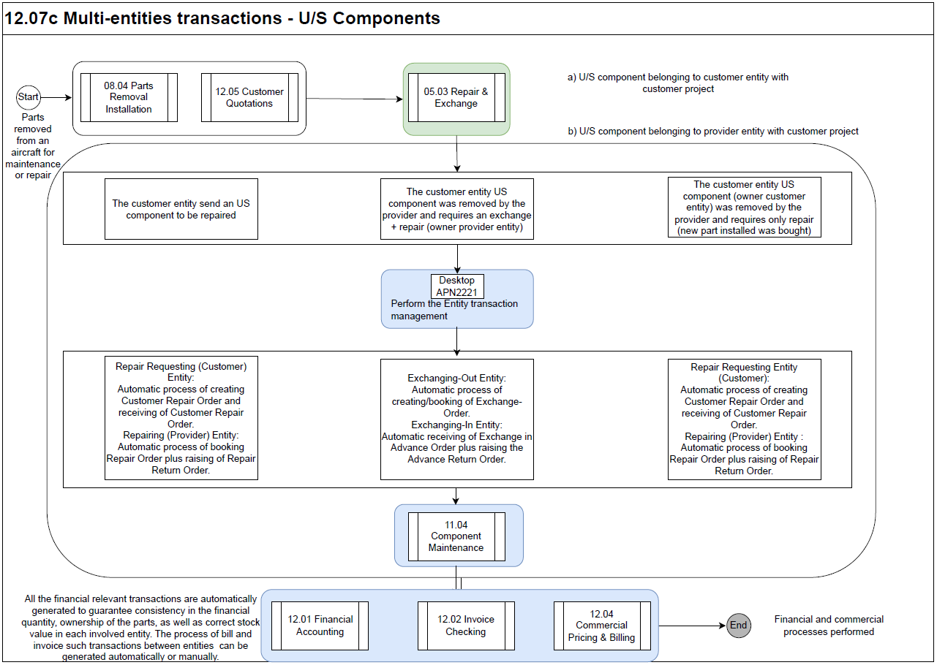

Process Design Questions

# | Question | Answer
1 | Are the orders issued using the company code or the department code? What are the owner codes for each entity?
2 | Is there only one Financial System for all entities, or each entity has its own financial system?
3 | How is the Procurement Dpt structured? Does a single department issue orders for all entities? If yes, is there a group of users responsible per type of Material or per Entity? If no, is there a Procurement Dpt per entity? Are they allowed to see the orders of the other entities?
4 | How is the property of parts divided? Is it the case that only the AIRLINE can own Rotables and the MRO can only own Rotable tools and all the consumables? Can the MRO buy and own Rotables to be used on their external customer aircraft? Is the MRO allowed to use AIRLINE Rotables in their external customer aircraft? In case of the AIRLINE - does the MRO need to give priority to use the AIRLINE own Rotables first?
5 | The Advance Reorder Proposal is not per entity but per station. How do you manage stock levels per entity?
6 | When selecting the part request in the WO, even if there are parts available in other entities, should they appear as available or not? (Stock logic settings of parameter 1417 and contract management)
7 | Who will be responsible to create part numbers, a single dpt or several departments? The part number classification have to be the same for all companies. E.g. if a part is classified as a rotable in one company, then it must also be the same in the others.
8 | What does Procurement Dpt need to see in Parts Consumption Forecast? Red or Green if there are parts available in other entities?
9 | How is the Stores Dpt structured? A single department handling all entities' parts or a single department per entity?
10 | Who creates the WP - the MRO or the AIRLINE? (For project allocation purposes)  Do entities subcontract labor between themselves?
11 | How do you identify the time bookings of the customer’s entity technicians in order to be able to exclude them from the bill?
12 | Are there different currency exchange rates per entity?
13 | How many AP dpt exist to do the invoice checking in AMOS? Is there any access restrictions for viewing invoices of other entities?
14 | Are all entities using the same accounting standards (for example: stock valuation method; fiscal year end…?) If not, is it possible to standardize? If not, what are the reasons (internal or external) for not being able to standardize?
15 | Is manual change of owner and entity allowed? In which cases? How do you control this in order to be able to invoice it?
16 | How is the invoice numbering defined? Will you use invoice numbers generated by the Financial System or AMOS-generated invoice numbers? (Parameter 809)
17 | How should the interfaces be set up in Multi-entity environment?
18 | Which Financial ERP system do you need to integrate the data to? SAP; ORACLE, MS Dynamics, Navision, Axapta, Sage… other? Is there any middleware to be used?
19 | Who will be responsible to monitor the Logs of scheduler tasks and interfaces and correct the errors?
20 | Which project and default bill account should be used for intercompany transactions?
21 | Who should initiate the process in ETM?
22 | Do you require any approval process for the orders or invoices in ETM?
23 | Is Automated ETM sale transaction at pickslip necessary?
24 | How is the shipping process of parts between entities (the physical move of parts) linked to the ETM process?
25 | Label booking of parts: Is production allowed to install a component belonging to other entity without a Purchase, Exchange or Loan order? If yes, how do you bill the usage of the part - with or without owner change?
26 | Are the parts received under a customer repair order in one entity (MRO) and belonging to an external customer, sent to another entity for repair using ETM?
27 | In ETM:  Is the debit account (ex: GR/IR) in the invoice checking process the same as for invoices of external suppliers?  Is the Credit account (ex: Material sales) in the billing process the same as for bills to external customers?
28 | Is there VAT for the intercompany transactions?
29 | What are the commercial conditions between entities for material sales, exchange, loan, repair?  Are the commercial conditions applicable to all transactions for all entities or the conditions are different?  Is it possible to set up a contract with the conditions?

Data Source Mapping

Data Sources | Description | Volume / Manual / Automatic / Static / Dynamic
 | -/- | -/-

Other Software Used

Other Softwares | Used by: | Description
-/- | -/- | -/-

AMOS Configuration

Process specific configuration programmes
AMOS APN | Notes
1940 – Financial Entity Administration | The entry point for the financial configuration is the setup of the single or multi financial entities. Here, the user is going to configure the entity address (coming from the address APN53), entity owner, the functional (not mandatory) and the local entity currency (coming from the currency management APN355)
355 – Currencies table | List of the available currencies which can be used in AMOS. The currency rates can be updated either manually or automatically imported via interface.
59 – Part Administration | The creation/modification/classification of the part in AMOS have significant financial impacts. The following part’s attributes have financial impacts especially when one of those attributes change: the material class, material type, FA Type, fixed asset flag, tool flag, repairable flag. Those attributes are relevant to setup the financial transactions in the APN1658.
1664 – Chart of Accounts | Usually, the CoA numbers are the same as the financial ERP. The user defines the CoA within the pre-defined structure proposed by AMOS and generated automatically after importing the default financial transaction in APN1658.
1658 – Financial Transaction Definition | Each financial-relevant transaction/movement in AMOS is identified by a code, called voucher mode (VM). Voucher modes are transaction-specific, e.g. B1 = Receiving of Material, YE = Rotable removal from aircraft, and thus, can be used to define each financial transaction’s logic. Complete list of voucher modes may be found in Basic-Data Administration (APN:18)- ‘Voucher Mode’ table.
781 – Define FA Qty calculation | Each company has internal regulations and processes describing the criteria that need to be fulfilled if the parts should be counted in its financial quantity. In AMOS this is configured in Define FA Qty Calculation (APN:781) program.  The Financial Quantity is the quantity of material that is used for calculation of the Financial Stock Value.
2365 – Financial Configuration | See bellow in the Parameter paragraph b.

Basic Data

Basic Data Table | Notes
Cost centers | If the entities are using different cost centers the recommendation is to create all codes in this table.
Tax Codes | If the entities are using different financial systems (FS) with different tax codes, the recommendation is to create all codes in this table.
Charges | If there are different accounts per charges, the recommendation is to create charges per entity.
Payment modes and payment conditions | If the entities are using different FS with different codes, the recommendation is to create all codes in these tables and identify per entity.
Material type | The codes must be standardized across all entities.
Invoice Accounting | Define rules to select a debit account to post on when an invoice is closed.
Bank Account | Define the bank account number of the provider entity in the currency of bill.

Parameters

Parameter Code | Parameter Name | Notes
1569 | Default Financial Entity
1595 | Entity Related Accounting
1601 | Activate the functional average price
1604 | Currency in entity transaction management
1617 | Entity Transaction Billing/Invoicing Mode
1627 | Price for Rotables in ETM
1628 | Price for Consumables in ETM

Workflows

Workflow Number | Workflow Name | Workflow Setup Notes
115 | Put part on pickslip | This workflow may be used to control accessibility of parts in Pickslip confirmation between entities in multi-entity environment. For instance, if a part belongs to one entity, then the other entity should not be allowed to pickslip it. Use conditions part_entity <> psl_project_entity
309 | Entity transaction Header Action | This Workflow contains the transaction header data. It will be triggered by the Entity Transaction manager at different time.
310 | Entity Transaction Detail Action | This Workflow contains a transaction detail data. It will be triggered by the Entity Transaction manager for each detail at different time.
387 | Issue Entity Transaction | This workflow is triggered before the booking of a pickslip/picking list Item, after the Pickslip Item workflow. A specific action can be set in order to sell the part from its entity to another before the bookings. It is also possible to generate an Exchange in Advance Transaction when the picksliped part is a Rotable. It can be useful in case the consumption costs need to be tracked under a specific entity which is not the part's current one.
388 | Automatic Entity Sales Transaction failed | This workflow is triggered only when an automatic sales transaction booked by the 387 - Issue Entity Sales Transaction workflow fails. If the workflow rule leads to conditional abort, the pickslip Item booking will be aborted. If not, the pickslip booking will continue without changing the owner.

Scheduled Tasks

Scheduled Task Reference | Frequency | Notes
PartFAEntityInitialization | Once: when new entity is created
FinancialSanityCheck | Weekly: for multi-entity check service
InitializeAddressEntityAccounting | Once: only when parameter 1595 entity related accounting is activated
FunctionalPriceInitializationTask | Once: only when parameter 1601 activate the functional average price is activated

API’s & Interfaces

Reference | Direction | Trigger | Frequency
TRANSFER GL | OUT |  | Daily
EXPORT INVOICE | OUT |  | TBD
IMPORT INVOICE | IN |  | TBD
TRANSFER BILLING | OUT |  | TBD

UAT Guidance

1 | Create 2 project numbers for the provider entity and customer entity in APN306
2 | Perform a sales/purchase transaction between 2 entities – book and invoice - check the validation and the output in case of errors
3 | Check the transactions in GL respectively for each entity
4 | Perform a loan transaction between the 2 entities – specify the loaned part and received part – check the validation and the output in case of errors
5 | Perform an exchange between the 2 entities - check the validation and the output in case of errors
6 | Perform an exchange in advance check the validation and the output in case of errors
7 | Perform a repair between the 2 entities - check the validation and the output in case of errors

Annex – Additional Info
-/-

